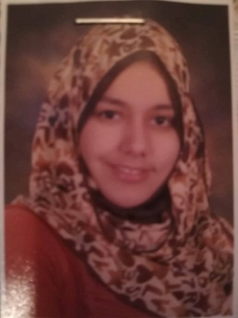
SAMAR HUSSIEN KAMEL
Sohag, Egypt · 01066731384
samer.abdelrahman@med.sohag.edu.eg
Assistant Lecturer- Sohag Faculty of medicine
Hepatology and Gastroentrology assistant lecturer focused on creating positive environment in which students can learn.
SKILLS
• Presentation Skills
• Decision Making
• Teamwork
• Research
TECHNICAL SKILLS
• Ultrasonography: Liver biopsy, abscess drainage, HCC intervention
• Endoscopy: diagnostic and intervention
LANGUAGES
• English: Excellent

INTERESTS
• Community Work
• Swimming
• Travel
• Chess
EXPERIENCE
• Training basic emergency medicine in different specialties
• Basic of ECG, ABG
• Outpatient Clinic
RESIDENT PHYSICIAN IN TROPIACAL AND GASTROENTROLOGY DEPARTMENT SOHAG UNIVERSITY HOSPITAL
5\2015-5\2018
• Management of patients in emergency room: Hematemesis, hepatic encephalopathy.
• Follow up of the In-patient cases.
• Dealing with out-patient cases.
• Observation of Intermediate Care Unit.
• Working as Administrative Doctor of the department.
• Lectures of Hepatology and Gastroenterology medicine.
• Clinical Rounds.
• Organizing Exams.
• Training young doctors ultrasonography and endoscopy.
• Researches.
TEACHING EXPERIENCE
TROPICAL MEDICINE
FACULTY OF MEDICINE- SUHAG UNIVERSITY
• Teaching how to take medical history
• Teaching clinical examination
• Teaching management of Hepatic diseases
• Sharing in putting the curriculum and its assessment
Courses
: 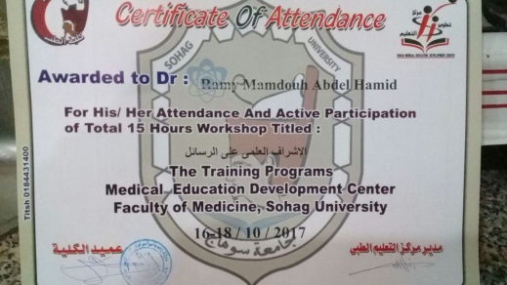 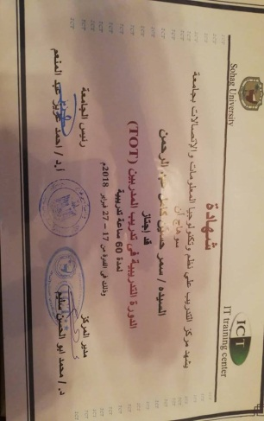 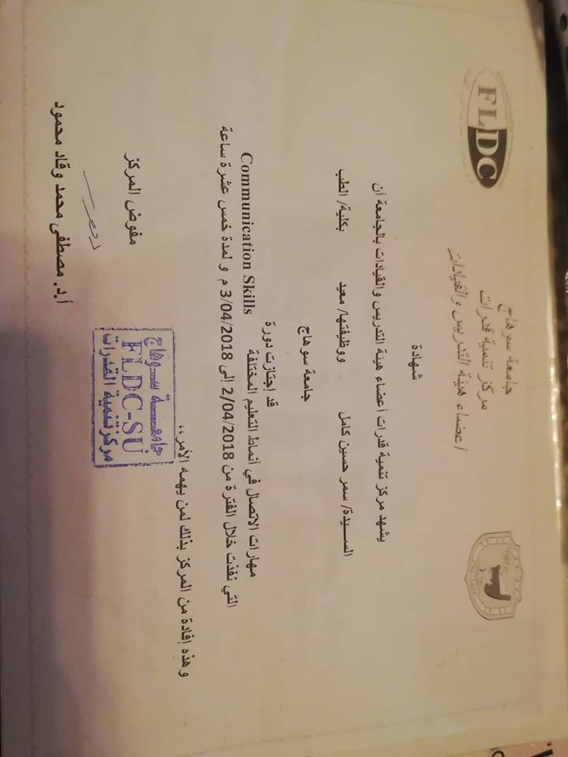 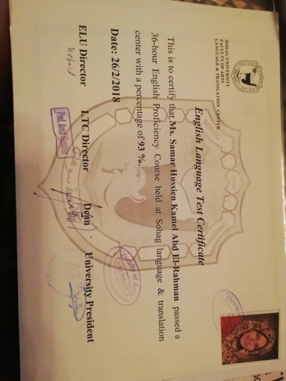 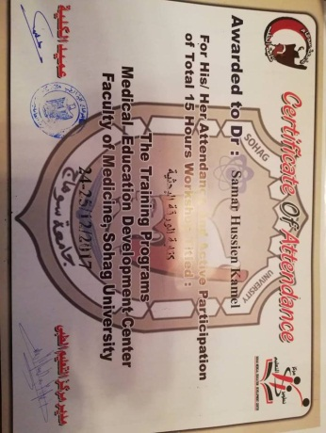

CONFERENCES & COURSES
• Advanced course of intervention radiology for HCC (04/2018 – Present)
• International publishing of Research (04/2018 – 04/2018)
• Research Team Management (03/2018 – 03/2018)
• Aswan GastroHep 2 Conference (02/2018 – 02/2018)
• Endoscopy Workshop of Aswan GastroHep 2 Conference (02/2018 – 02/2018)
• The 2nd Annual Scientific Conference of Tropical Medicine of South Valley University
(08/2017 – 08/2017)
• The 12th Middle East Hands on Training Course on GI Endoscopy (12/2015 – 12/2015)
• The 8th Hepatology and Gastroentrology Post Graduate Course (12/2015 – 12/2015)
• Sohag Annual Conference and Workshop of Basic and Advanced GIT Endoscopy and ERCP
(02/2015 – 02/2015)
• Energy Therapy (02/2010 – 02/2010)
• The 2nd International conference of The Arab Society for Medical Resaerch (11/2008 – 11/2008)
• The Success Skills (11/2008 – 11/2008)
• Research Training Program for Medical Students (07/2008 – 10/2008)
• Blood transfusion.
• Viral Hepatitis prevention.
• Avian Flu Project.
• Breast Cancer project.

